“Suggested” weekend camp kit list
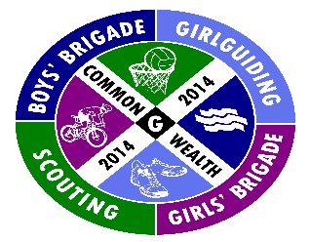
Sleeping Equipment
- Sleeping bag
- Roll mat or thermarest
- Nightwear
- Extra hoodie/ warm hat
Personal Care
- Toothbrush and Toothpaste
- Soap/shower gel/ Shampoo
- Towel
- Anything else you would normally include in your wash kit
Clothing
- Full uniform
- Underwear
- Long trousers (preferably not denim jeans)
- Shorts
- T-shirts
- Trainers
- Gloves
- Warm socks
- Jumper/hoody
- Windproof jacket
- Waterproof jacket and trousers
- Waterproof walking boots or wellington boots
- Swimwear
- Sun cap
Other Items
- Water bottle
- Torch (with extra batteries)
- Medicine, clearly labelled with name and dosage (if required)
- Glasses, hearing aid etc. if required
- Sun lotion
- Day sac

